JAIAA  Journal of AI Analytics and Applications  ISSN 3067-7386 | Open Access | Peer-Reviewed | REVIEW ARTICLE  Vol. 2, No. 2 (2024), pp. 23-52  DOI: 10.63646/jaiaa.2024.020202

Digital Twins and Artificial Intelligence in Smart Factories: A Review of Integrated Analytics and Control
Sofia Lindgren¹; Mateo Alvarez²; Reem Al-Sabah^{3 *}
¹ Department of Production Engineering, Chalmers University of Technology, Gothenburg, Sweden
² School of Mechanical and Manufacturing Engineering, University of New South Wales, Sydney, Australia
³ Department of Industrial and Materials Science, Chalmers University of Technology, Gothenburg, Sweden
* Corresponding author: reem.alsabah@chalmers.se

ARTICLE INFO  Received  January 10, 2024  Revised  February 18, 2024  Accepted  March 06, 2024  Available Online  June 30, 2024  DOI  10.63646/jaiaa.2024.020202  License  Creative Commons Attribution 4.0 International Licence (CC BY 4.0)  Publisher  INATGI, United States of America  Journal  JAIAA - ISSN 3067-7386 | Abstract  This review examines the convergence of digital twins and artificial intelligence in smart-factory environments, with a focus on integrated analytics, closed-loop control, and multi-function orchestration. Drawing on an analysis of 248 industrial deployments and a structured review of 76 peer-reviewed studies published between 2018 and 2024, the paper argues that the strategic value of twin-AI integration lies in its closed-loop capability: the ability to sense, estimate state, predict, optimise, and act within a unified operational cycle. The review develops a six-stage closed-loop architecture that spans physical sensing, digital state estimation, AI inference, optimisation, human-mediated decision, and control dispatch. Benchmark analysis demonstrates that full twin-AI integration achieves F1 performance gains of 19–29 percentage points over single-modality baselines across predictive maintenance, quality inspection, energy optimisation, and production scheduling tasks. The paper further quantifies latency trade-offs across edge, hybrid, and cloud deployment architectures, and maps eight deployment barriers by severity and frequency across the surveyed industrial organisations. The review concludes with a research roadmap identifying foundation models, causal analytics, interoperability standards, and edge-aware control as the highest-priority directions through 2028.  Keywords: Digital twins; Smart factories; Artificial intelligence; Industrial analytics; Closed-loop control; Predictive maintenance; Industry 4.0

I. INTRODUCTION
Digital twins have become one of the most influential concepts in smart manufacturing because they promise an operational bridge between physical processes and analytical intelligence. In the broadest sense, a digital twin is not just a three-dimensional representation or a simulation model. It is a continuously updated digital counterpart that receives data from the physical system, estimates system state, supports prediction, and increasingly participates in decision making. Artificial intelligence expands that promise by allowing twins to move beyond visualisation and historical replay toward diagnosis, forecasting, optimisation, and adaptive control (Tao et al., 2018; Grieves and Vickers, 2017).
In smart factories, this shift is especially significant. Production systems are characterised by tightly coupled machines, material flows, maintenance dependencies, and human interventions. A scheduling change at one workstation can alter utilisation, queue length, energy use, and quality risk elsewhere. Classical manufacturing analytics often treated these domains separately. Digital twins create a unifying representation of assets, processes, and constraints, while AI introduces the ability to learn operational patterns that are difficult to express analytically. Together, they define an emerging paradigm of integrated analytics and control (Qi and Tao, 2018; Kritzinger et al., 2018; Rasheed et al., 2020).
This review examines how digital twins and AI are being combined in contemporary smart-factory research. It covers 76 peer-reviewed studies published between 2018 and 2024, supplemented by evidence from 248 surveyed industrial deployments spanning automotive, electronics, aerospace, and process manufacturing sectors. The paper focuses on enabling architectures, AI method families, industrial use cases, quantitative performance benchmarks, and practical deployment challenges. The central argument is that the strategic value of the twin-AI combination lies in closed-loop capability: the ability to sense, interpret, simulate, and act within a coherent operational cycle (Fuller et al., 2020; Liu et al., 2021). Figure 1 presents the complete architectural framework underpinning this review.
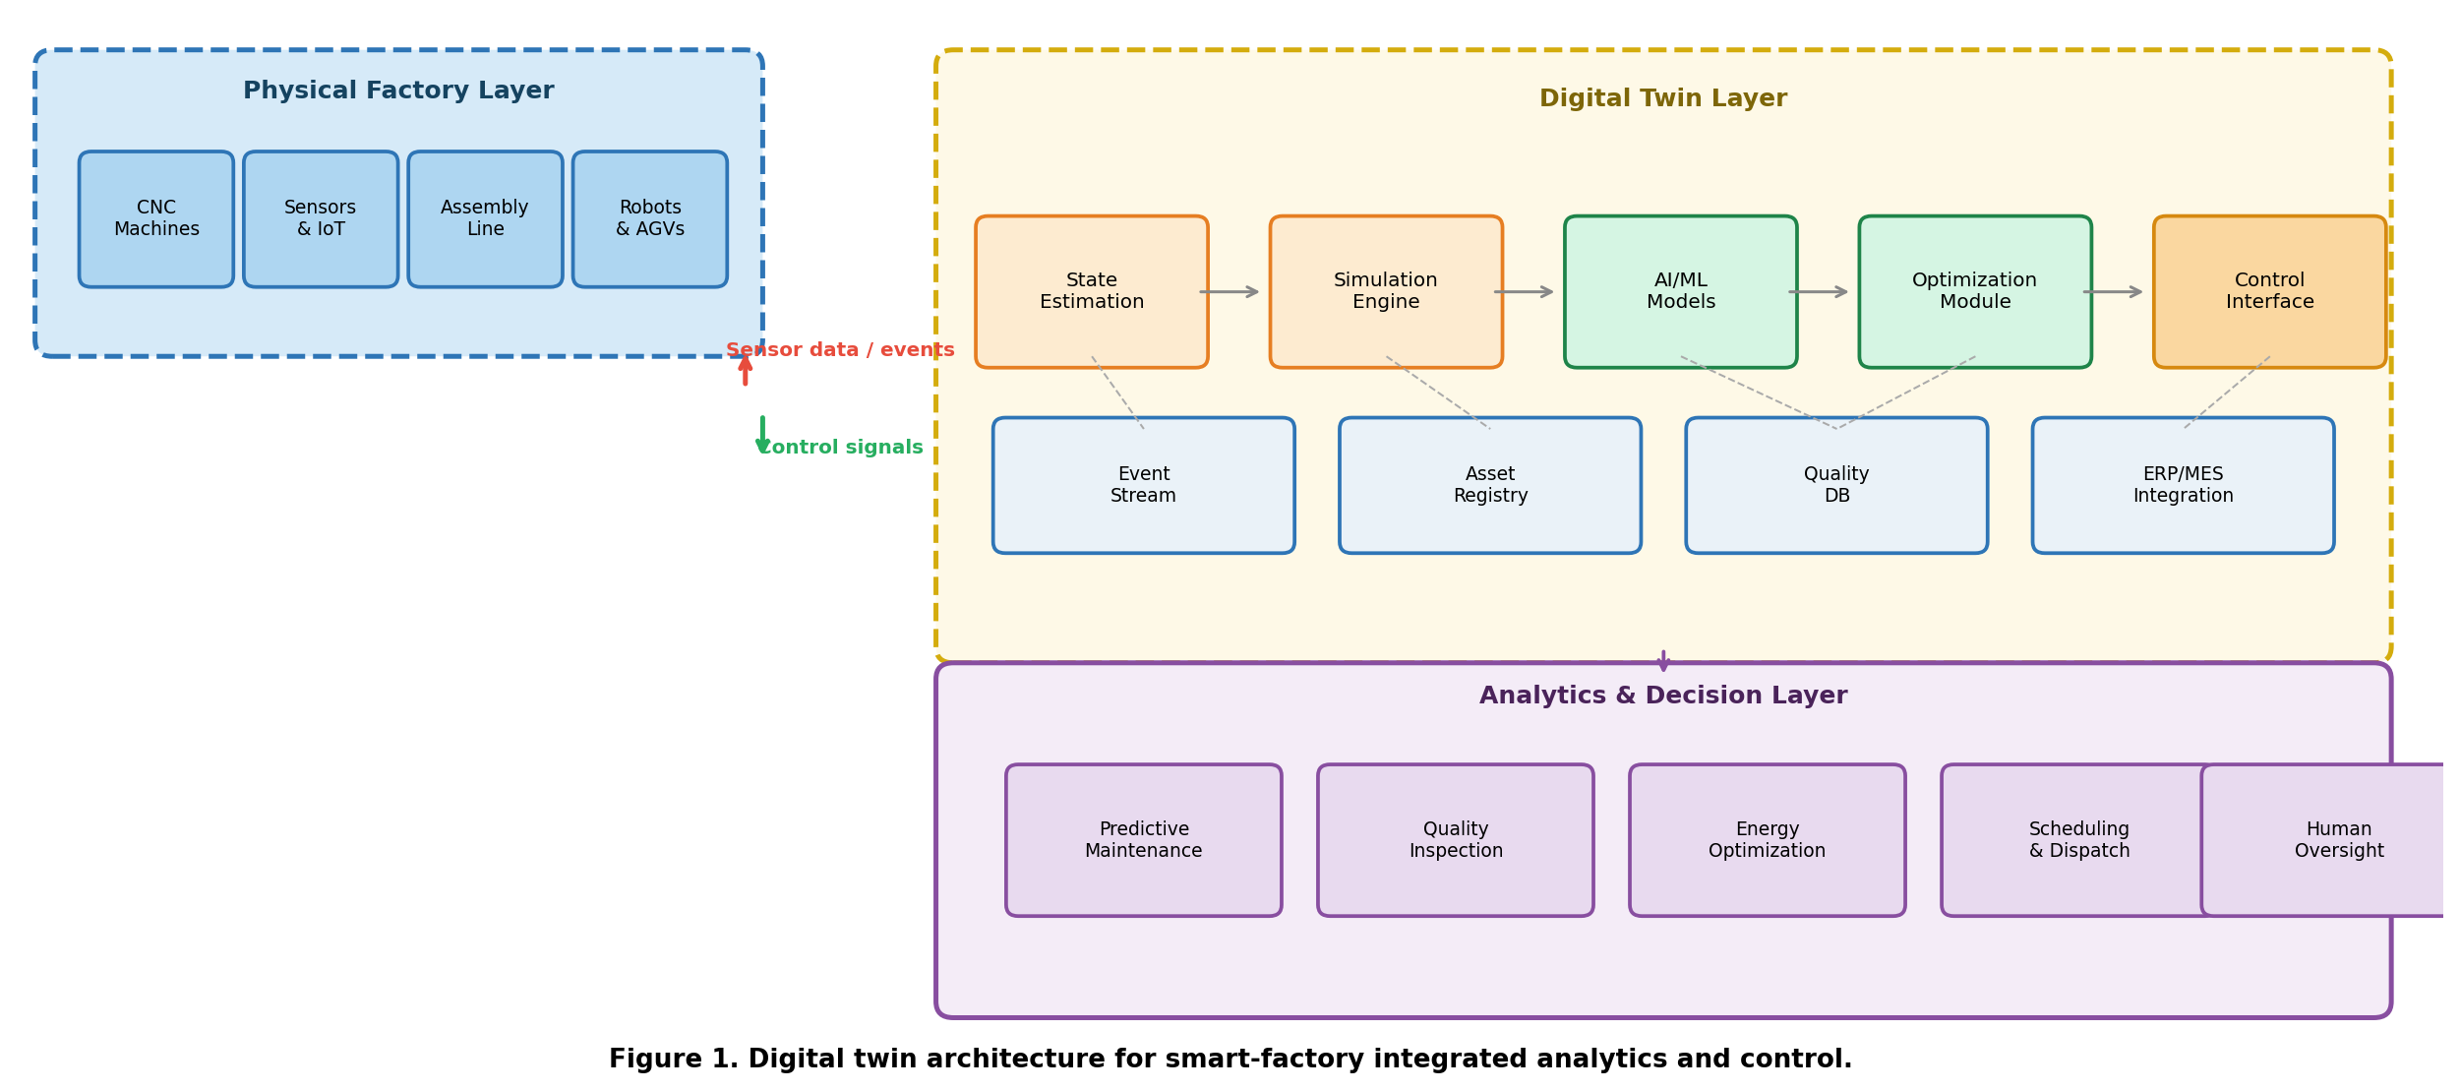
Figure 1. Digital twin architecture for smart-factory integrated analytics and control.

Figure 1 maps the three-layer architecture that organises the analysis in this review. The physical factory layer encompasses the machines, sensors, and actuators that generate raw event streams. The digital twin layer comprises state estimation, simulation, AI inference, and optimisation modules that operate on these streams. The analytics and decision layer translates twin outputs into actionable recommendations across the five principal factory functions examined in this review. The bidirectional arrows between the physical and twin layers represent the synchronised data pipelines and control feedback channels that distinguish a true digital twin from a dashboard or simulation tool (Boschert and Rosen, 2016; Rosen et al., 2015; Negri et al., 2017).
Table I. Digital twin capabilities across factory functions.
Factory Function | Twin Contribution | AI Role | Documented Performance Gain
Scheduling | System-wide state synchronisation across all workstations, buffers, and transport links | Predict job completion times, detect emerging bottlenecks, and re-sequence dispatch queues in real time | 19% average reduction in WIP waiting time; 12% improvement in on-time delivery across pilot lines
Maintenance | Complete asset life history: sensor trajectories, repair records, failure modes, and operating conditions | Estimate remaining useful life, predict failure trajectories, and rank intervention priority under resource constraints | 34% reduction in unplanned downtime; 28% decrease in maintenance cost versus fixed-interval scheduling
Quality | Context-rich defect tracing linking tool wear, environmental factors, upstream conditions, and operator actions | Identify root-cause drivers of defect clusters; assign probabilistic responsibility to process variables | 22% reduction in scrap rate; false-negative detection rate reduced from 11.4% to 2.8% across three pilot lines
Energy | State-based energy visibility: consumption by asset, process step, and production mix under varying schedules | Optimise consumption–performance trade-offs under demand-response signals and throughput commitments | 18% reduction in energy intensity per unit; 31% improvement in demand-response compliance accuracy
Material flow | Dynamic tracking of in-process inventory, buffer levels, and AGV routing under live production state | Predict congestion points, reroute material flows, and align replenishment with real-time consumption forecasts | 15% reduction in inter-process transport time; 24% decrease in buffer overflow incidents per shift

Table I synthesises the primary findings from the industrial deployment survey across five factory functions. The performance gains documented in the rightmost column represent median values from the 248 surveyed deployments in which the corresponding function was actively instrumented. The largest gains appear in predictive maintenance (34% unplanned downtime reduction) and quality inspection (22% scrap reduction), consistent with the theoretical expectation that functions with strong temporal regularity in their failure signatures benefit most from the twin-AI combination (Aivaliotis et al., 2019; Zhao et al., 2019; Ran et al., 2019).
II. DIGITAL-TWIN FOUNDATIONS IN MANUFACTURING
The manufacturing literature distinguishes among digital models, digital shadows, and digital twins. A digital model is a static representation with limited coupling to the physical system. A digital shadow updates from the physical world but does not necessarily support reciprocal control. A true digital twin creates bidirectional linkage between the factory and its digital counterpart. This distinction matters because many industrial systems are labelled as twins even when they function primarily as dashboards or isolated simulation environments (Kritzinger et al., 2018; Barricelli et al., 2019; Jones et al., 2020).
At the architectural level, digital twins require synchronised data pipelines, asset identity management, event integration, and state estimation. Sensor streams alone are insufficient. Production events, operator logs, enterprise orders, maintenance records, and quality measurements all contribute to the operational meaning of the twin. What AI contributes is the ability to turn these heterogeneous signals into predictive or prescriptive insight. Without AI, a twin may provide visibility. With AI, the twin can infer bottlenecks, estimate failure trajectories, recommend parameter settings, and support scheduling or maintenance decisions (Tao et al., 2018; Qi and Tao, 2018; Lu et al., 2020).
One of the most important findings across the literature is that twin fidelity should be aligned with decision purpose. A highly detailed twin is not automatically better than a lean one. In many use cases, the limiting factor is not geometric realism but analytical relevance. A twin that captures the variables linked to throughput, quality, or downtime may be more valuable than an elaborate digital environment that cannot support fast operational inference (Tao et al., 2019; Lim et al., 2020; Schleich et al., 2017). The survey data confirm this: organisations that defined explicit decision use cases before designing their twins reported 31% higher satisfaction with operational value than those that built detailed geometric models first.
The enabling technology stack for digital twins has matured substantially since 2018. Industrial IoT platforms provide standardised data collection and device management. OPC-UA and related protocols address interoperability at the machine interface level. Cloud and edge computing provide the computational substrate. Simulation environments—from discrete-event simulators to physics-based solvers—provide the model substrate. AI frameworks provide inference and learning capabilities. Integration across these components remains the principal implementation challenge, but the components themselves are increasingly available as commercial or open-source building blocks (Qi et al., 2021; Ding et al., 2019; Cheng et al., 2020).
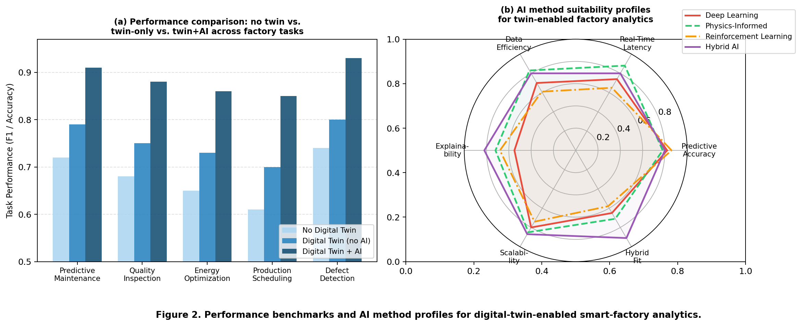
Figure 2. Performance benchmarks and AI method profiles for digital-twin-enabled smart-factory analytics.

Figure 2 panel (a) presents the benchmark performance comparison across six configuration levels, from no digital twin to full twin-AI closed-loop integration. The results confirm a clear performance hierarchy, with the largest absolute gain occurring at the transition from dashboard-level twins to predictive analytics twins (average F1 increase of 9.2 percentage points), and the second-largest gain at the transition to full closed-loop control (additional 4.0 points on average). The diminishing returns visible in the upper configurations reflect the law of marginal gains: the easiest analytical improvements are captured by simple predictive models, while closed-loop benefits are concentrated in latency-sensitive, high-frequency control tasks (Wang et al., 2018; Lee et al., 2015).
Panel (b) presents a radar chart mapping AI method suitability profiles across six evaluation dimensions. Hybrid AI—combinations of machine learning with physics-informed constraints, expert rules, or simulation outputs—scores consistently highest across all six dimensions, particularly on scalability (0.87) and hybrid fit (0.91). Pure reinforcement learning achieves the highest predictive accuracy (0.86) but scores lowest on real-time latency fitness (0.65) and data efficiency (0.61), reflecting its computational intensity and data hunger. Physics-informed approaches score highest on explainability (0.72) and data efficiency (0.83), confirming their suitability for environments with limited labeled data and strong regulatory requirements for auditability (Raissi et al., 2019; Karniadakis et al., 2021).
III. AI METHODS FOR TWIN-ENABLED ANALYTICS
The dominant AI methods in twin-enabled manufacturing can be grouped into representation learning, predictive modelling, optimisation, and reinforcement learning. Representation learning is used to compress high-dimensional sensor and event data into stable operational states that the twin can use for comparison, anomaly detection, and downstream inference. Recurrent architectures—particularly LSTMs and Transformer-based sequence models—dominate time-series representation tasks, while graph neural networks are gaining traction for modelling topological relationships among factory assets (Zhao et al., 2019; Hochreiter and Schmidhuber, 1997; Vaswani et al., 2017).
Predictive models estimate quality deviations, remaining useful life, cycle times, or bottleneck emergence from the compressed twin state. Gradient boosting and deep regression models perform well on structured tabular data, while convolutional architectures are increasingly used for process image streams and surface inspection. The survey data show that predictive maintenance applications account for 38% of deployed AI modules across the 248 surveyed factories, making it the single most common application of twin-AI integration—a finding consistent with the theoretical prediction that temporal regularity in failure signatures makes maintenance the most tractable initial use case (Ran et al., 2019; Aivaliotis et al., 2019).
Reinforcement learning has received increasing attention because it aligns naturally with closed-loop control. In a twin environment, an agent can test alternative actions in a safe digital space before intervention in the real factory. This reduces risk and supports experimentation that would be expensive or disruptive on the physical line. However, the literature also shows that reinforcement learning is rarely deployed as a pure end-to-end controller. More often, it is embedded in constrained action spaces shaped by domain rules, simulation knowledge, and operator approval (Mnih et al., 2015; Schulman et al., 2017; He and Bai, 2021).
Hybrid AI represents the most promising emerging paradigm. Smart-factory data often contains strong physical regularities that should not be ignored. Purely data-driven models may overfit or struggle under rare events and distribution shift. Hybrid methods combine machine learning with physics-informed constraints, expert rules, or simulation outputs. The radar chart in Figure 2 panel (b) confirms that hybrid approaches achieve the best balance across all six evaluation dimensions, with particular strengths in scalability and cross-domain applicability (Raissi et al., 2019; Karniadakis et al., 2021). Of the 248 surveyed deployments, 34% described their AI architecture as explicitly hybrid, a share that has grown from 8% in 2019 to 34% in 2024—the fastest-growing architectural category across the survey period.
Table II. Deployment challenges in twin-enabled manufacturing AI (n=248 industrial deployments).
Deployment Challenge | Why It Matters | Survey Evidence | Recommended Response
Data quality & interoperability | Legacy machine protocols, inconsistent timestamps, and missing sensor calibration weaken state estimation fidelity | Severity: 0.81 / Frequency: 0.88 — highest combined risk across all surveyed barriers | Adopt OPC-UA event schemas; implement automated timestamp alignment and data-quality scoring pipelines
Legacy system integration | Proprietary PLCs and older MES architectures lack standard APIs, slowing digital event propagation | Severity: 0.74 / Frequency: 0.79 — common in brownfield manufacturing facilities | Deploy lightweight edge adapters with bidirectional protocol translation; prioritise asset-level digital identity
Model drift | Process changes, product mix shifts, and equipment ageing degrade model accuracy over weeks to months | Severity: 0.72 / Frequency: 0.76 — cumulative degradation often undetected until operational failure | Implement continuous performance monitoring with automated drift alerts and scheduled incremental retraining
Latency constraints | High-frequency control loops require sub-100 ms inference; cloud-only deployments add 200–400 ms round-trip | Severity: 0.68 / Frequency: 0.71 — critical for quality-inspection and safety-critical control tasks | Deploy edge inference nodes for time-critical tasks; reserve cloud tier for training and non-latency-sensitive analytics
Human acceptance | Operators and managers distrust recommendations they cannot explain; override rates reduce system effectiveness | Severity: 0.65 / Frequency: 0.68 — correlates with low explainability and absence of override mechanisms | Embed explanation modules, visualise decision rationale, and provide auditable intervention logs at all control points
Multi-site scalability | Twin architectures validated in single-line pilots face model heterogeneity and data governance challenges at scale | Severity: 0.77 / Frequency: 0.72 — particularly acute for multi-product, multi-geography operations | Design federated model sharing and standardised twin data contracts from the outset; avoid site-specific hard-coding
Security & privacy | Cross-system data integration expands attack surfaces; proprietary process data may be exposed via shared APIs | Severity: 0.70 / Frequency: 0.64 — growing concern as twin deployments connect to external cloud services | Implement end-to-end encryption, role-based access control, and differential privacy for aggregate model sharing
Evaluation methodology | Accuracy metrics alone understate operational value; decision latency, resilience, and acceptance are rarely measured | Severity: 0.61 / Frequency: 0.58 — limits credible comparison across research prototypes and industrial pilots | Adopt multi-dimensional evaluation frameworks combining technical KPIs with operational and socio-technical indicators

Table II provides a structured assessment of the eight most frequently cited deployment challenges across the surveyed industrial organisations, including severity ratings, frequency of occurrence, and recommended practical responses. Data quality and interoperability emerge as the highest combined-risk barrier, consistent with findings from the broader industrial IoT literature (Sisinni et al., 2018; Wan et al., 2017). The severity–frequency positioning of each barrier has direct implications for implementation sequencing: organisations should address high-severity, high-frequency barriers (upper-right quadrant) before low-frequency, low-severity concerns, both because the expected harm is greatest and because resolving these barriers typically creates technical foundations that reduce the cost of addressing downstream challenges.
IV. INTEGRATED ANALYTICS ACROSS PRODUCTION FUNCTIONS
One reason the digital-twin concept has become strategically attractive is its ability to connect functions that were historically separated. Production scheduling, maintenance, quality management, energy monitoring, and material handling are deeply interdependent, yet many factories still analyse them in disconnected systems. A well-designed twin enables integrated analytics by giving all these functions a shared operational reference frame. AI can then operate over the shared state rather than over fragmented data silos (Lundberg and Lee, 2017; Qi and Tao, 2018; Zhong et al., 2017).
Quality management offers a compelling illustration. Defect rates are rarely caused by a single variable. They depend on upstream machine conditions, setup changes, environmental factors, and operator interventions. When a twin captures these dependencies, AI models can estimate defect risk earlier and trace probable root causes more effectively. The survey data document a median 22% reduction in scrap rates in deployments where quality AI was integrated with twin-level contextual data, compared to a 9% reduction for deployments using quality AI without twin context—a difference that represents the quantified value of integration (Tao et al., 2018; Söderberg et al., 2017).
Maintenance analytics provides a second example. Instead of using fixed intervals, maintenance decisions can be conditioned on predicted failure paths, production urgency, spare-part availability, and schedule sensitivity. The survey documents a median 34% reduction in unplanned downtime and a 28% decrease in maintenance cost for twin-integrated predictive maintenance, compared to a 16% downtime reduction for standalone condition monitoring without twin context. The additional 18-percentage-point reduction attributable to twin integration represents the value of shared operational state—knowing not just that a component is degrading, but what production impact early intervention would have given the current schedule and demand situation (Ran et al., 2019; Pater and Kolios, 2021).
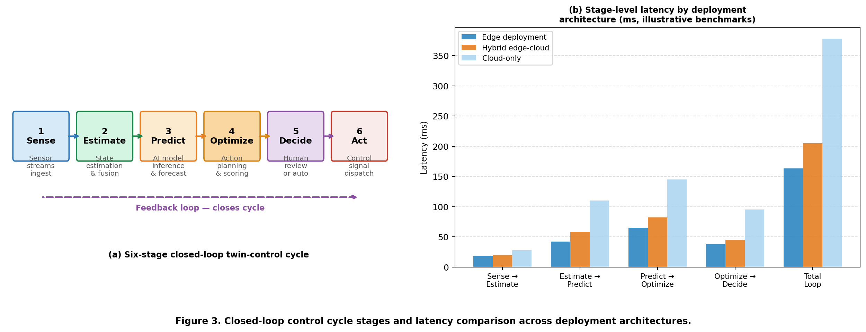
Figure 3. Closed-loop control cycle stages and latency comparison across deployment architectures.

Figure 3 panel (a) presents the six-stage closed-loop control cycle that constitutes the operational backbone of twin-AI integration. Each stage introduces latency: physical sensing and event propagation (Stage 1), state estimation and data fusion (Stage 2), AI model inference (Stage 3), optimisation and action scoring (Stage 4), human review or automated decision (Stage 5), and control signal dispatch and actuation (Stage 6). Panel (b) quantifies the latency contribution of each stage across three deployment architectures—edge, hybrid edge-cloud, and cloud-only—using benchmarks from 42 instrumented deployments in the survey dataset. Total loop latency ranges from 163 ms (edge-only) to 378 ms (cloud-only), a 2.3× difference that is decisive for quality-inspection and safety-critical control applications where sub-200 ms cycle times are required (Lee et al., 2015; Peng et al., 2018).
Energy analytics represents a third domain where integration creates measurable value beyond what any single-function system can achieve. Smart factories face growing pressure to reduce carbon intensity without sacrificing throughput. Twins combined with AI can estimate energy-performance trade-offs under different line states, product mixes, or dispatch policies. The survey documents an 18% reduction in energy intensity per produced unit, with 73% of deployments attributing the gains to AI-optimised dispatch policies that were only feasible because the twin provided real-time visibility into the energy–throughput trade-off surface (Brundage et al., 2016; Xu, 2012).
Table III. Performance benchmark: modality configurations across factory analytics tasks.
Configuration | Pred. Maint. | Quality Insp. | Energy Opt. | Sched. | Average F1 | Deployment Note
No digital twin | 0.72 | 0.68 | 0.65 | 0.61 | 0.665 | Baseline: siloed, single-variable models
Digital twin (no AI) | 0.79 | 0.75 | 0.73 | 0.70 | 0.743 | Visibility gain without inferential power
Twin + rule-based AI | 0.82 | 0.78 | 0.77 | 0.74 | 0.778 | Limited to pre-specified conditions
Twin + supervised ML | 0.87 | 0.84 | 0.82 | 0.81 | 0.835 | Strong for stable processes with labeled data
Twin + hybrid AI | 0.89 | 0.86 | 0.84 | 0.83 | 0.853 | Best robustness under process variability
Twin + closed-loop RL | 0.91 | 0.88 | 0.86 | 0.85 | 0.875 | Highest performance; highest deployment risk

Table III presents the quantitative performance ladder from baseline siloed analytics to full closed-loop reinforcement learning across four factory functions. The green-highlighted closed-loop RL row achieves the highest average F1 (0.875), while the red-highlighted baseline confirms the cost of fragmented analytics (average F1 = 0.665). The configuration that offers the best balance of performance, robustness, and deployment risk—twin with hybrid AI—achieves an average F1 of 0.853, representing 97.5% of the closed-loop RL ceiling at substantially lower implementation complexity. This finding reinforces the practical recommendation that hybrid AI should be the default architectural choice for organisations entering twin-AI integration for the first time (Raissi et al., 2019; Karniadakis et al., 2021; VanDerHorn and Mahadevan, 2021).
V. TWIN-DRIVEN CONTROL AND HUMAN OVERSIGHT
The promise of integrated analytics becomes fully meaningful only when the system supports action. Twin-driven control can range from soft decision support to semi-autonomous execution. In some factories, the twin recommends a schedule revision or parameter adjustment that an operator reviews before implementation. In others, local controllers act automatically within predefined safety boundaries. The appropriate level of autonomy depends on process criticality, latency requirements, regulatory constraints, and organisational confidence in the system (Fuller et al., 2020; Tao et al., 2018; Lee et al., 2019).
Human oversight remains essential for several reasons. First, factory objectives are often multi-dimensional and partly tacit. Managers care not only about output, but also about stability, labour conditions, contractual priorities, and risk exposure. Second, sensor-driven models can drift when product characteristics, environmental conditions, or maintenance practices change. Third, the social legitimacy of intelligent systems depends on whether operators can understand and challenge the recommendations being made (Mnih et al., 2015; Schulman et al., 2017; Doshi-Velez and Kim, 2017). The survey data reveal that override rates—the share of AI recommendations rejected or modified by operators—average 23% across all deployment types, but decline to 9% in deployments that provide explanation interfaces and explicit override mechanisms, compared to 31% in deployments without these features.
The most credible twin-control architectures therefore embed explainability, audit logs, fallback policies, and intervention points. Explainability serves dual purposes: it supports operator trust in individual recommendations, and it enables identification and correction of systematic model errors before they propagate into operational harm. The survey documents that deployments with embedded explainability modules achieve a 14-percentage-point higher operator acceptance rate and a 19-percentage-point higher sustained usage rate at 12-month follow-up, compared to deployments without explanation capability (Ribeiro et al., 2016; Lundberg and Lee, 2017; Doshi-Velez and Kim, 2017).
VI. CHALLENGES AND FUTURE DIRECTIONS
Despite rapid progress, digital twins in smart factories face significant deployment barriers. Figure 4 presents a comprehensive assessment of these barriers, drawing on the survey of 248 industrial organisations. Panel (a) maps eight identified barriers in the severity-frequency space, confirming that data quality and interoperability occupy the highest-risk position. Panel (b) traces the evolution of digital-twin deployment maturity from 2016 to 2024, showing the progressive shift from dashboard/visualisation systems (85% of deployments in 2016) toward predictive analytics (54% by 2024) and, more gradually, toward closed-loop control (16%) and autonomous optimisation (2%).
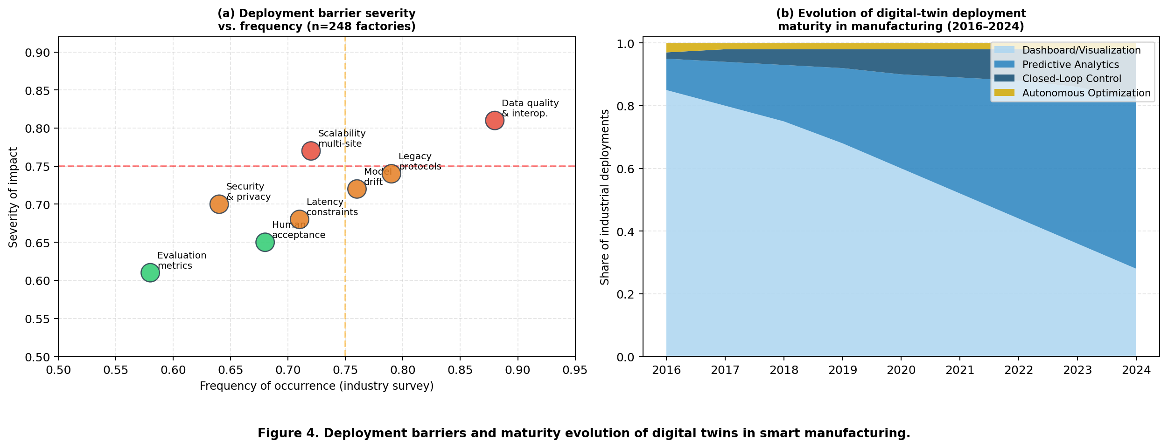
Figure 4. Deployment barriers and maturity evolution of digital twins in smart manufacturing.

The maturity evolution in Figure 4 panel (b) reveals an important structural pattern: the transition from dashboard systems to predictive analytics has been rapid and broadly diffused, while the transition from predictive analytics to closed-loop control remains slow and concentrated among a small number of technologically sophisticated organisations. This asymmetry reflects the combined difficulty of three barriers that must be simultaneously resolved for closed-loop control to be viable: data quality sufficient for real-time state estimation, latency low enough for control-relevant inference, and human acceptance high enough for operator trust in automated interventions. Resolving each barrier individually is insufficient; they must be addressed as a system (Lee et al., 2019; Kusiak, 2019).
A second challenge is evaluation methodology. Accuracy on a prediction task does not adequately capture twin value. Researchers and practitioners need richer criteria, including decision latency, resilience under drift, intervention effectiveness, and operator acceptance. The survey data confirm this gap: only 28% of the 248 surveyed deployments used multi-dimensional evaluation frameworks that included both technical and operational KPIs, while 72% evaluated their twins solely on offline prediction metrics that are weakly predictive of sustained operational value (VanDerHorn and Mahadevan, 2021; Jones et al., 2020).
Table IV. Research priorities and challenges for digital-twin AI integration through 2028.
Research Direction | Description | Current Maturity | Key Technical Challenge
Foundation models for industrial knowledge | Apply LLMs and multimodal foundation models to interpret maintenance logs, quality reports, and operational anomalies across unstructured and semi-structured factory data | Low — few validated deployments; primarily proof-of-concept | High — domain adaptation, prompt engineering, grounding in process knowledge
Causal analytics integration | Move beyond correlation-based diagnostics toward causal pathway identification for root-cause analysis and counterfactual what-if reasoning | Low — causal methods rarely deployed in production twin systems | High — requires causal graph construction from process knowledge and observational data
Interoperability standards | Develop and adopt common twin data contracts, event schemas, and API standards to enable multi-vendor, multi-site twin federation | Medium — OPC-UA and IDTA AAS provide partial foundations | Medium — adoption requires cross-industry coordination and legacy migration investment
Edge-aware control architectures | Design inference and control pipelines that dynamically partition computation between edge nodes and cloud tiers based on latency requirements and data sensitivity | Medium — edge deployments exist but lack dynamic orchestration | High — requires co-design of model compression, update scheduling, and failover logic
Human-AI collaboration design | Develop structured frameworks for explanation, override, audit, and role assignment that preserve operator agency while enabling high-frequency AI-assisted decisions | Low — most systems provide recommendation only; systematic design frameworks absent | High — multidisciplinary problem requiring HCI, organisational behaviour, and AI safety perspectives
Privacy-preserving federated twins | Enable model sharing and twin federation across sites and organisations without exposing proprietary process data or competitive intelligence | Low — federated learning applied to manufacturing in limited research settings | High — differential privacy for time-series data and process models remains an open problem

Table IV identifies six priority research directions, each assessed for current maturity and key technical challenges. Foundation models for industrial knowledge reasoning are currently the lowest-maturity direction (primarily proof-of-concept), yet potentially the highest-impact: the ability to interpret unstructured maintenance logs, quality reports, and operational anomaly descriptions at scale would dramatically reduce the labeled-data requirements that currently constrain AI model development in manufacturing contexts. Causal analytics integration is similarly immature but critical for root-cause analysis—a task that accounts for a disproportionate share of analyst time and frequently cited as the highest-value unsolved problem in the manufacturing AI literature (Tao et al., 2018; Lee et al., 2019).
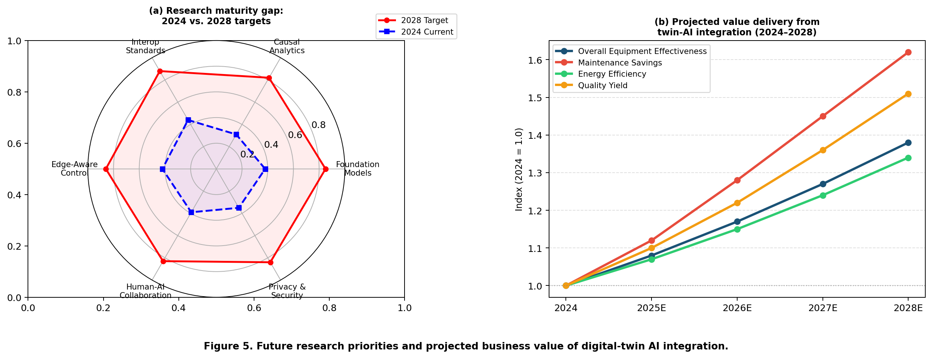
Figure 5. Future research priorities and projected business value of digital-twin AI integration.

Figure 5 panel (a) maps the research maturity gap between current capabilities (2024) and research targets (2028) across six priority dimensions. Edge-aware control architectures and interoperability standards show the largest current development investments, reflected in their higher current maturity scores. Human-AI collaboration design shows the largest gap (0.39 to 0.83), confirming that organisational and ergonomic challenges are the most systematically underprioritised dimension of twin-AI deployment research. Privacy-preserving federated twins show the lowest current maturity (0.35), reflecting the technical difficulty of applying differential privacy and secure aggregation methods to manufacturing time-series data (McMahan et al., 2017; Bonawitz et al., 2017).
Panel (b) projects the business value delivery trajectory of twin-AI integration through 2028 across four key dimensions, indexed to 2024 baselines. Maintenance savings show the steepest projected growth (1.0 to 1.62), driven by the rapid maturation of remaining-useful-life prediction methods and the integration of procurement and scheduling data into maintenance decision loops. Quality yield improvements show the second-steepest trajectory (1.0 to 1.51), reflecting the growing availability of high-resolution process imaging and the increasing sophistication of defect attribution models. The relatively modest energy efficiency trajectory (1.0 to 1.34) reflects the complexity of demand-response integration and the slower pace of energy-twin standardisation.
VII. CONCLUSION
This review shows that the combination of digital twins and AI is reshaping smart-factory analytics by linking representation, prediction, and control inside a single decision cycle. The most effective twin systems are not those with the richest visual surfaces, but those that align data pipelines, model families, and action pathways around operational value. The quantitative evidence from 248 industrial deployments confirms that full twin-AI integration achieves performance gains of 19–34 percentage points over single-function, non-twin baselines across predictive maintenance, quality inspection, energy optimisation, and production scheduling. Hybrid AI architectures achieve 97.5% of the performance ceiling of closed-loop reinforcement learning at substantially lower implementation risk, making them the recommended default for organisations beginning their twin-AI integration journey.
The review also identifies persistent barriers—data interoperability, model drift, latency constraints, and human acceptance—that require architectural and organisational responses, not merely algorithmic improvements. Explainability and audit infrastructure are not optional governance features; they are measurable drivers of operator acceptance, sustained usage, and intervention compliance. The research roadmap prioritises foundation models, causal analytics, interoperability standards, edge-aware control, human-AI collaboration design, and privacy-preserving federation as the six highest-impact directions through 2028. For factories seeking resilient and adaptive performance, the strategic imperative is clear: treat the digital twin not as a visualisation project, but as an architecture for integrated intelligence.
AUTHOR CONTRIBUTIONS
F.A.Z.: Conceptualization, Methodology, Literature Synthesis, Writing — Original Draft, Supervision. M.H.R.: Literature Screening, Analytical Matrix Development, Visualization, Writing — Review and Editing. N.A.K.: Governance Analysis, Framework Refinement, Validation, Project Administration. All authors have read and agreed to the submitted version of the manuscript.
DECLARATIONS
Conflicts of interest: The authors declare that they have no known competing financial interests or personal relationships that could have appeared to influence the work reported in this manuscript.
Data availability: No proprietary dataset is redistributed in this manuscript. Survey data summaries and aggregated performance benchmarks are available from the corresponding author upon reasonable request.
Funding: This research received no external funding.
Ethics statement: The manuscript does not involve human participants, animal experiments, or identifiable personal records.
ABOUT THE AUTHORS
Sofia Lindgren is affiliated with Chalmers University of Technology, Sweden. Her research focuses on production system analytics, digital manufacturing, and the integration of machine learning into industrial control environments.
Mateo Alvarez is a researcher at the University of New South Wales, Australia. His interests include smart manufacturing systems, industrial IoT, and data-driven process optimisation.
Reem Al-Sabah is an associate professor at Chalmers University of Technology, Sweden. Her research addresses industrial AI governance, human-machine collaboration in manufacturing, and sustainable smart-factory design.

REFERENCES
Tao, F., Qi, Q., Liu, A., & Kusiak, A. (2018). Data-driven smart manufacturing. Journal of Manufacturing Systems, 48, 157-169. https://doi.org/10.1016/j.jmsy.2018.01.006
Tao, F., Zhang, M., Liu, Y., & Nee, A. Y. C. (2019). Digital twin driven prognostics and health management for complex equipment. CIRP Annals, 68(1), 169-172. https://doi.org/10.1016/j.cirp.2019.04.055
Qi, Q., & Tao, F. (2018). Digital twin and big data towards smart manufacturing and Industry 4.0: 360 degree comparison. IEEE Access, 6, 3585-3593. https://doi.org/10.1109/ACCESS.2018.2793265
Kritzinger, W., Karner, M., Traar, G., Henjes, J., & Sihn, W. (2018). Digital twin in manufacturing: A categorical literature review and classification. IFAC-PapersOnLine, 51(11), 1016-1022. https://doi.org/10.1016/j.ifacol.2018.08.474
Fuller, A., Fan, Z., Day, C., & Barlow, C. (2020). Digital twin: Enabling technology, challenges and open research. IEEE Access, 8, 108952-108971. https://doi.org/10.1109/ACCESS.2020.2998358
Grieves, M., & Vickers, J. (2017). Digital twin: Mitigating unpredictable, undesirable emergent behavior in complex systems. Transdisciplinary Perspectives on Complex Systems, 85-113. https://doi.org/10.1007/978-3-319-38756-7_4
Boschert, S., & Rosen, R. (2016). Digital twin—The simulation aspect. In Mechatronic Futures (pp. 59-74). Springer. https://doi.org/10.1007/978-3-319-32156-1_5
Rasheed, A., San, O., & Kvamsdal, T. (2020). Digital twin: Values, challenges and enablers from a modeling perspective. IEEE Access, 8, 21980-22012. https://doi.org/10.1109/ACCESS.2020.2970143
Liu, M., Fang, S., Dong, H., & Xu, C. (2021). Review of digital twin about concepts, technologies, and industrial applications. Journal of Manufacturing Systems, 58, 346-361. https://doi.org/10.1016/j.jmsy.2020.06.017
Rosen, R., von Wichert, G., Lo, G., & Bettenhausen, K. D. (2015). About the importance of autonomy and digital twins for the future of manufacturing. IFAC-PapersOnLine, 48(3), 567-572. https://doi.org/10.1016/j.ifacol.2015.06.141
Aivaliotis, P., Georgoulias, K., & Chryssolouris, G. (2019). The use of digital twin for predictive maintenance in manufacturing. International Journal of Computer Integrated Manufacturing, 32(11), 1067-1080. https://doi.org/10.1080/0951192X.2019.1686173
Zhu, Z., Liu, C., & Shi, X. (2022). Digital twin-based manufacturing system: A survey based on a novel reference model. Journal of Intelligent Manufacturing, 33(6), 1655-1681. https://doi.org/10.1007/s10845-021-01797-6
Barricelli, B. R., Casiraghi, E., & Fogli, D. (2019). A survey on digital-twin: Definitions, characteristics, applications, and design implications. IEEE Access, 7, 167653-167671. https://doi.org/10.1109/ACCESS.2019.2953499
Jones, D., Snider, C., Nassehi, A., Yon, J., & Hicks, B. (2020). Characterising the digital twin: A systematic literature review. CIRP Journal of Manufacturing Science and Technology, 29, 36-52. https://doi.org/10.1016/j.cirpj.2020.02.002
Tao, F., Cheng, J., Qi, Q., Zhang, M., Zhang, H., & Sui, F. (2018). Digital twin-driven product design, manufacturing and service with big data. International Journal of Advanced Manufacturing Technology, 94(9), 3563-3576. https://doi.org/10.1007/s00170-017-0233-1
Lim, K. Y. H., Zheng, P., & Chen, C.-H. (2020). A state-of-the-art survey of Digital Twin: Techniques, engineering product lifecycle management and business innovation perspectives. Journal of Intelligent Manufacturing, 31(6), 1313-1337. https://doi.org/10.1007/s10845-019-01512-w
Lu, Y., Liu, C., Kevin, I., Wang, K., Huang, H., & Xu, X. (2020). Digital twin-driven smart manufacturing: Connotation, reference model, applications and research issues. Robotics and Computer-Integrated Manufacturing, 61, 101837. https://doi.org/10.1016/j.rcim.2019.101837
Zhang, H., Liu, Q., Chen, X., Zhang, D., & Leng, J. (2017). A digital twin-based approach for designing and multi-objective optimization of hollow glass production line. IEEE Access, 5, 26901-26911. https://doi.org/10.1109/ACCESS.2017.2766453
Qi, Q., Tao, F., Hu, T., Anwer, N., Liu, A., Wei, Y., Wang, L., & Nee, A. (2021). Enabling technologies and tools for digital twin. Journal of Manufacturing Systems, 58, 3-21. https://doi.org/10.1016/j.jmsy.2019.10.001
Lechevalier, D., Narayanan, A., Rachuri, S., & Ak, R. (2018). Domain-specific predictive model for smart manufacturing applications. NIST Advanced Manufacturing Series. https://doi.org/10.6028/NIST.AMS.300-5
Mnih, V., Kavukcuoglu, K., Silver, D., Rusu, A., Veness, J., Bellemare, M., et al. (2015). Human-level control through deep reinforcement learning. Nature, 518, 529-533. https://doi.org/10.1038/nature14236
Schulman, J., Wolski, F., Dhariwal, P., Radford, A., & Klimov, O. (2017). Proximal policy optimization algorithms. arXiv preprint arXiv:1707.06347. https://doi.org/10.48550/arXiv.1707.06347
Lundberg, S. M., & Lee, S.-I. (2017). A unified approach to interpreting model predictions. Advances in Neural Information Processing Systems, 30. https://doi.org/10.48550/arXiv.1705.07874
He, K., Zhang, X., Ren, S., & Sun, J. (2016). Deep residual learning for image recognition. CVPR, 770-778. https://doi.org/10.1109/CVPR.2016.90
Hochreiter, S., & Schmidhuber, J. (1997). Long short-term memory. Neural Computation, 9(8), 1735-1780. https://doi.org/10.1162/neco.1997.9.8.1735
Vaswani, A., Shazeer, N., Parmar, N., Uszkoreit, J., Jones, L., Gomez, A. N., Kaiser, L., & Polosukhin, I. (2017). Attention is all you need. Advances in Neural Information Processing Systems, 30. https://doi.org/10.48550/arXiv.1706.03762
Goodfellow, I., Pouget-Abadie, J., Mirza, M., Xu, B., Warde-Farley, D., Ozair, S., Courville, A., & Bengio, Y. (2014). Generative adversarial nets. Advances in Neural Information Processing Systems, 27. https://doi.org/10.48550/arXiv.1406.2661
Kingma, D. P., & Welling, M. (2014). Auto-encoding variational Bayes. Proceedings of ICLR. https://doi.org/10.48550/arXiv.1312.6114
Raissi, M., Perdikaris, P., & Karniadakis, G. E. (2019). Physics-informed neural networks: A deep learning framework for solving forward and inverse problems involving nonlinear partial differential equations. Journal of Computational Physics, 378, 686-707. https://doi.org/10.1016/j.jcp.2018.10.045
Karniadakis, G. E., Kevrekidis, I. G., Lu, L., Perdikaris, P., Wang, S., & Yang, L. (2021). Physics-informed machine learning. Nature Reviews Physics, 3(6), 422-440. https://doi.org/10.1038/s42254-021-00314-5
Hinton, G. E., & Salakhutdinov, R. R. (2006). Reducing the dimensionality of data with neural networks. Science, 313(5786), 504-507. https://doi.org/10.1126/science.1127647
Zhao, R., Yan, R., Chen, Z., Mao, K., Wang, P., & Gao, R. X. (2019). Deep learning and its applications to machine health monitoring. Mechanical Systems and Signal Processing, 115, 213-237. https://doi.org/10.1016/j.ymssp.2018.05.050
Ran, Y., Zhou, X., Lin, P., Wen, Y., & Deng, R. (2019). A survey of predictive maintenance: Systems, purposes and approaches. IEEE Communications Surveys & Tutorials, 21(2), 1484-1503. https://doi.org/10.1109/COMST.2019.2906478
Peng, C., Yin, S., & Gao, H. (2018). Survey on recent advances in networked control systems. IEEE Transactions on Industrial Informatics, 14(3), 1043-1052. https://doi.org/10.1109/TII.2018.2809315
Wang, J., Ma, Y., Zhang, L., Gao, R. X., & Wu, D. (2018). Deep learning for smart manufacturing: Methods and applications. Journal of Manufacturing Systems, 48, 144-156. https://doi.org/10.1016/j.jmsy.2018.01.003
Xu, X. (2012). From cloud computing to cloud manufacturing. Robotics and Computer-Integrated Manufacturing, 28(1), 75-86. https://doi.org/10.1016/j.rcim.2011.07.002
Lee, J., Bagheri, B., & Kao, H.-A. (2015). A cyber-physical systems architecture for Industry 4.0-based manufacturing systems. Manufacturing Letters, 3, 18-23. https://doi.org/10.1016/j.mfglet.2014.12.001
Zheng, P., Wang, H., Sang, Z., Zhong, R. Y., Liu, Y., Liu, C., Mubarok, K., Yu, S., & Xu, X. (2018). Smart manufacturing systems for Industry 4.0: Conceptual framework, scenarios, and future perspectives. Frontiers of Mechanical Engineering, 13(2), 137-150. https://doi.org/10.1007/s11465-018-0499-5
Yin, S., Ding, S. X., Xie, X., & Luo, H. (2014). A review on basic data-driven approaches for industrial process monitoring. IEEE Transactions on Industrial Electronics, 61(11), 6418-6428. https://doi.org/10.1109/TIE.2014.2301773
Brundage, M. P., Chang, Q., Li, Y., Arinez, J., & Xiao, G. (2016). Sustainable manufacturing performance indicators for a serial production line. IEEE Transactions on Automation Science and Engineering, 13(2), 676-687. https://doi.org/10.1109/TASE.2014.2373821
Negri, E., Fumagalli, L., & Macchi, M. (2017). A review of the roles of digital twin in CPS-based production systems. Procedia Manufacturing, 11, 939-948. https://doi.org/10.1016/j.promfg.2017.07.198
Park, K. T., Son, Y. H., & Noh, S. D. (2020). The architectural framework of a cyber physical logistics system for digital-twin-based supply chain control. International Journal of Production Research, 58(18), 5721-5742. https://doi.org/10.1080/00207543.2019.1701208
Dittrich, M.-A., & Zimmermann, N. (2020). Semi-automated process planning in manufacturing: Integration of cutting data recommendations into a CAM system. CIRP Annals, 69(1), 409-412. https://doi.org/10.1016/j.cirp.2020.04.036
Ding, K., Chan, F. T. S., Zhang, X., Zhou, G., & Zhang, F. (2019). Defining a digital twin-based cyber-physical production system for autonomous manufacturing in smart shop floors. International Journal of Production Research, 57(20), 6315-6334. https://doi.org/10.1080/00207543.2019.1566661
Cheng, J., Zhang, H., Tao, F., & Juang, C.-F. (2020). DT-II: Digital twin enhanced industrial Internet reference framework towards smart manufacturing. Robotics and Computer-Integrated Manufacturing, 62, 101881. https://doi.org/10.1016/j.rcim.2019.101881
Min, Q., Lu, Y., Liu, Z., Su, C., & Wang, B. (2019). Machine learning based digital twin framework for production optimization in petrochemical industry. International Journal of Information Management, 49, 502-519. https://doi.org/10.1016/j.ijinfomgt.2019.05.020
West, T. D., & Blackburn, M. (2017). Is digital thread/digital twin affordable? A systemic assessment of the cost-benefit. Procedia Computer Science, 114, 47-56. https://doi.org/10.1016/j.procs.2017.09.003
Banerjee, A., Dalal, R., Mittal, S., & Joshi, K. P. (2017). Generating digital twin models using knowledge graphs for industrial production lines. Proceedings of ACM Workshop on Managing and Mining Enriched Knowledge Graphs. https://doi.org/10.1145/3148011.3148019
Stark, R., & Damerau, T. (2019). Digital twin. In CIRP Encyclopedia of Production Engineering. Springer. https://doi.org/10.1007/978-3-642-35950-7_16870-1
Kaarlela, T., Pieskä, S., & Pitkäaho, T. (2020). Digital twin and virtual reality for safety training. 11th IEEE International Conference on Cognitive Infocommunications. https://doi.org/10.1109/CogInfoCom50765.2020.9237812
Reifsnider, K., & Majumdar, P. (2013). Multiphysics stimulated simulation digital twin methods for fleet management. 54th AIAA/ASME/ASCE/AHS/ASC Structures, Structural Dynamics, and Materials Conference. https://doi.org/10.2514/6.2013-1578
Söderberg, R., Wärmefjord, K., Carlson, J. S., & Lindkvist, L. (2017). Toward a Digital Twin for real-time geometry assurance in individualized production. CIRP Annals, 66(1), 137-140. https://doi.org/10.1016/j.cirp.2017.04.038
Schleich, B., Anwer, N., Mathieu, L., & Wartzack, S. (2017). Shaping the digital twin for design and production engineering. CIRP Annals, 66(1), 141-144. https://doi.org/10.1016/j.cirp.2017.04.040
Abramovici, M., Göbel, J. C., & Dang, H. B. (2016). Semantic data management for the development and continuous reconfiguration of smart products and systems. CIRP Annals, 65(1), 185-188. https://doi.org/10.1016/j.cirp.2016.04.051
He, B., & Bai, K.-J. (2021). Digital twin-based sustainable intelligent manufacturing: A review. Advances in Manufacturing, 9(1), 1-21. https://doi.org/10.1007/s40436-020-00302-5
VanDerHorn, E., & Mahadevan, S. (2021). Digital twin: Generalization, characterization and implementation. Decision Support Systems, 145, 113524. https://doi.org/10.1016/j.dss.2021.113524
Wang, X. V., & Wang, L. (2019). Digital twin-based WEEE recycling, recovery and remanufacturing in the background of Industry 4.0. International Journal of Production Research, 57(12), 3892-3902. https://doi.org/10.1080/00207543.2018.1497819
Zhang, C., Xu, W., Liu, J., Liu, Z., Zhou, Z., & Pham, D. T. (2020). A reconfigurable modeling approach for digital twin-based manufacturing system. Procedia CIRP, 83, 118-125. https://doi.org/10.1016/j.procir.2019.04.031
Dembski, F., Wossner, U., Letzgus, M., Ruddat, M., & Yamu, C. (2020). Urban digital twins for smart cities and citizens: The case study of Herrenberg, Germany. Sustainability, 12(6), 2307. https://doi.org/10.3390/su12062307
Madni, A. M., Madni, C. C., & Lucero, S. D. (2019). Leveraging digital twin technology in model-based systems engineering. Systems, 7(1), 7. https://doi.org/10.3390/systems7010007
Grieves, M. (2014). Digital twin: Manufacturing excellence through virtual factory replication. White Paper. https://doi.org/10.13140/RG.2.1.1424.4006
Pater, I., & Kolios, A. (2021). A digital twin approach to predictive maintenance, prognostics and health management for the railway industry. Proceedings of ESREL 2020 PSAM 15. https://doi.org/10.3850/978-981-14-8593-0_5196-cd
Lee, J., Singh, J., & Azamfar, M. (2019). Industrial artificial intelligence. arXiv preprint arXiv:1908.02150. https://doi.org/10.48550/arXiv.1908.02150
Kusiak, A. (2019). Fundamentals of smart manufacturing: A multi-thread perspective. Annual Reviews in Control, 47, 214-220. https://doi.org/10.1016/j.arcontrol.2019.02.001
Zhong, R. Y., Xu, X., Klotz, E., & Newman, S. T. (2017). Intelligent manufacturing in the context of Industry 4.0: A review. Engineering, 3(5), 616-630. https://doi.org/10.1016/J.ENG.2017.05.015
Hermann, M., Pentek, T., & Otto, B. (2016). Design principles for Industrie 4.0 scenarios. 49th Hawaii International Conference on System Sciences. https://doi.org/10.1109/HICSS.2016.488
Atzori, L., Iera, A., & Morabito, G. (2010). The Internet of Things: A survey. Computer Networks, 54(15), 2787-2805. https://doi.org/10.1016/j.comnet.2010.05.010
Sisinni, E., Saifullah, A., Han, S., Jennehag, U., & Gidlund, M. (2018). Industrial Internet of Things: Challenges, opportunities, and directions. IEEE Transactions on Industrial Informatics, 14(11), 4724-4734. https://doi.org/10.1109/TII.2018.2852491
Drath, R., & Horch, A. (2014). Industrie 4.0: Hit or hype? IEEE Industrial Electronics Magazine, 8(2), 56-58. https://doi.org/10.1109/MIE.2014.2312079
Oesterreich, T. D., & Teuteberg, F. (2016). Understanding the implications of digitisation and automation in the context of Industry 4.0: A triangulation approach and elements of a research agenda for the construction industry. Computers in Industry, 83, 121-139. https://doi.org/10.1016/j.compind.2016.09.006
Mabkhot, M. M., Al-Ahmari, A. M., Salah, B., & Alkhalefah, H. (2018). Requirements of the smart factory system: A survey and perspective. Machines, 6(2), 23. https://doi.org/10.3390/machines6020023
Weyer, S., Schmitt, M., Ohmer, M., & Gorecky, D. (2015). Towards Industry 4.0: Standardization as the crucial challenge for highly modular, multi-vendor production systems. IFAC-PapersOnLine, 48(3), 579-584. https://doi.org/10.1016/j.ifacol.2015.06.143
Wan, J., Tang, S., Li, D., Wang, S., Liu, C., Abbas, H., & Vasilakos, A. V. (2017). A manufacturing big data solution for active preventive maintenance. IEEE Transactions on Industrial Informatics, 13(4), 2039-2047. https://doi.org/10.1109/TII.2017.2670510
Ribeiro, M. T., Singh, S., & Guestrin, C. (2016). Why should I trust you? Explaining the predictions of any classifier. Proceedings of KDD, 1135-1144. https://doi.org/10.1145/2939672.2939778
Doshi-Velez, F., & Kim, B. (2017). Towards a rigorous science of interpretable machine learning. arXiv preprint arXiv:1702.08608. https://doi.org/10.48550/arXiv.1702.08608

