Vol. 3, No. 1, pp.: 5-21, 2025
Benchmarking Real Trade and Multi-Regional Input–Output Databases for Applied Analytical Workflows: An Empirical Comparison of Coverage, Policy Readiness, and Use-Case Fit

Wei Zhang¹, Lin Chen^{2,*}, Mingyu Zhao¹
¹ School of Economics, Beijing Technology and Business University, Beijing 100048, China
² School of Management, University of Chinese Academy of Sciences, Beijing 100190, China
* lin.chen@ucas.edu.cn
Article Information
Received | 14 November 2024
Accepted | 10 March 2025
DOI | https://doi.org/10.63646/datamind.2025.030102

Abstract
The rapid expansion of trade and multi-regional input–output (MRIO) databases has created a new problem for applied researchers: the limiting factor is no longer the absence of data, but the difficulty of selecting a database whose structure matches the intended analytical task. This study benchmarks eight real databases that are widely used in trade, global value chain, and policy analysis—EXIOBASE 3, GTAP 10, GTAP 11, UNCTAD-Eora, the International Trade and Production Database for Estimation (ITPD-E), the WTO Structural Gravity Database, the CEPII Gravity Database, and BACI. Using a structured secondary-data coding design, each database is evaluated on seven dimensions: geographic coverage, granularity, temporal depth, environmental extensions, policy-readiness, openness, and application diversity. The coded dataset is analysed using descriptive statistics, principal component analysis, k-means clustering, and scenario-based suitability scoring. Three application scenarios are examined: sustainability footprint accounting, trade-policy counterfactual analysis, and export diversification intelligence. The results show a clear functional differentiation across database families. EXIOBASE 3 performs best in sustainability-oriented work because of its strong environmental accounts and high analytical richness. GTAP 11 ranks first for trade-policy counterfactual analysis because of its strong integration with computable general equilibrium and simulation workflows. BACI performs best for export diversification intelligence because of its product-level detail and deep time coverage. The article argues that database selection should be treated as a methodological decision with direct consequences for inference quality, reproducibility, and policy relevance. A practical matching framework is offered for researchers and developers who need to build database-aware analytical pipelines.
Keywords: trade databases; MRIO; structural gravity; global value chains; comparative benchmarking; policy analytics
1. Introduction
Databases are no longer passive repositories at the edge of empirical trade research. They increasingly shape what questions can be asked, what shocks can be simulated, how reproducibility is maintained, and how far a study can move from descriptive comparison to actionable policy inference. This shift is especially visible in work that links trade flows, production networks, environmental extensions, and bilateral frictions. Once the literature moved beyond single-country input–output tables and aggregate customs series, database architecture became part of the research design itself. Global MRIO systems made it possible to trace upstream and downstream interdependence, while structured gravity datasets made counterfactual policy work easier to implement and defend (Tukker and Dietzenbacher, 2013; Yotov, 2024).
The practical consequence is straightforward but often under-acknowledged: not all “big” trade databases are substitutes for one another. A database designed for footprint accounting is not automatically suitable for product-level diversification work. A database optimized for gravity estimation is not the best starting point for environmental spillover analysis. Yet many studies still select a database because it is familiar, easily downloadable, or already supported by existing code, rather than because its structure aligns with the analytical task. This matters because differences in temporal depth, sector resolution, environmental extensions, and policy calibration affect the conclusions that researchers draw from the same economic phenomenon (Tukker et al., 2009; Borchert et al., 2021).
The recent growth of open analytical ecosystems has made the issue even more pressing. Databases now travel into software packages, dashboards, reproducible notebooks, and automated policy tools. In this environment, the right question is not only which database is larger or newer, but which one provides the most suitable data architecture for a particular workflow. Databases such as EXIOBASE 3 and GTAP 11 are strong examples of this infrastructure turn: they do not merely store observations, they embed assumptions about sector aggregation, balance conditions, environmental accounting, and policy simulation (Stadler et al., 2018; Aguiar et al., 2022).
The present article responds to that challenge by writing a new study on a topic adjacent to the uploaded software paper, but with a different substantive centre of gravity. Instead of introducing a software package, it concentrates on real databases and their applications. The main aim is to benchmark a set of widely used trade and MRIO databases in a systematic, empirical, and decision-oriented way. The contribution is modest in form but useful in practice: it offers a transparent comparative framework for choosing among databases before model building begins.
Three research questions guide the analysis. First, how do major real-world databases differ when assessed along core methodological dimensions such as coverage, granularity, environmental extensions, and policy readiness? Second, do these databases cluster into meaningful families that correspond to different research logics? Third, which databases are best matched to three common analytical scenarios: sustainability footprint accounting, trade-policy counterfactual analysis, and export diversification intelligence?
To answer these questions, this study codes eight databases using a structured rubric derived from current database documentation and application-oriented studies. The coded matrix is then analysed using descriptive comparison, principal component analysis, k-means clustering, and scenario-weighted ranking. The empirical exercise does not replace database manuals, nor does it attempt to reproduce raw bilateral trade values or full MRIO tables. Instead, it treats databases as methodological infrastructures and compares them on the attributes that matter most for applied analytical workflows.
2. Database Landscape and Application Logic
The contemporary database landscape in trade and MRIO analysis can be grouped into three broad families. The first family consists of environmentally extended MRIO systems. These databases were built to connect production, consumption, and environmental pressure accounts across global supply chains. EXIOBASE is the most visible case in this family because it combines strong sector detail with rich environmental extensions and has become central to work on carbon footprints, material use, biodiversity pressure, and embodied land-use analysis (Wood et al., 2015; Bjelle et al., 2020; Davin et al., 2024).
The second family consists of economy-wide simulation databases built for counterfactual and computable general equilibrium work. GTAP is the clearest example. Its successive releases do not simply increase observations; they refine the benchmark structure used in policy modelling. This makes GTAP particularly attractive for tariff reform, carbon border adjustment, land-use, energy, and welfare simulations, where internal consistency and policy transmission matter more than extreme product detail (Aguiar et al., 2019; Aguiar et al., 2022; Korpar et al., 2023).
The third family includes bilateral trade and gravity-oriented databases. These are designed to support estimation rather than footprint accounting. CEPII Gravity, the WTO Structural Gravity Database, and ITPD-E belong to this family, although they differ in scope and intended use. CEPII provides rich dyadic covariates, the WTO platform provides consistent domestic and international manufacturing trade for structural-gravity work, and ITPD-E extends the logic by aligning production and trade data at the industry level for statistical estimation (Campos et al., 2021; Borchert et al., 2021). BACI sits nearby but follows a different route: it offers product-level customs detail that is especially valuable for export complexity, diversification, and quality analysis (Olvera and Spinola, 2025).
The existence of these families is not a weakness. On the contrary, it reflects the fact that the databases were designed to solve different empirical problems. Problems arise when one family is forced into the role of another. Product-level customs data can reveal fine patterns of specialization, but it does not automatically support economy-wide policy counterfactuals. MRIO systems can trace environmental spillovers and value-added chains, but they often impose aggregation choices that are unsuitable for narrowly defined product intelligence. Gravity datasets support clean econometric identification, but they do not by themselves provide environmental extension accounts (Steubing et al., 2022; Yotov, 2024).
A second reason database choice matters is that application areas are becoming more interconnected. Researchers now increasingly ask hybrid questions. They want to understand how trade shocks affect emissions, how logistics quality shapes GVC linkages, how sanctions propagate through sectoral production structures, or how lockdown policies translate into employment losses along interconnected value chains. Such questions require datasets that are not only large, but structurally compatible with the method chosen for inference (Taguchi and Zhao, 2022; Bai et al., 2022; Flach et al., 2024).
The final point from the literature is that database infrastructure has become central to reproducible science. As workflows move toward open software, versioned analytical pipelines, and multi-database robustness checks, database openness and standardization gain methodological importance. A database that is technically rich but difficult to access, compare, or document raises the cost of replication. Conversely, an open and well-documented database can produce more cumulative research value even if it is less detailed on one dimension (Font Vivanco, 2020; Steubing et al., 2022).
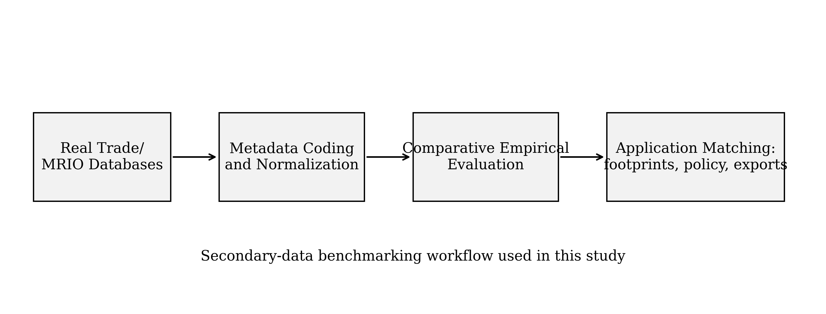
Figure 1. Analytical workflow for benchmarking real trade and MRIO databases.
Figure 1 makes clear that the empirical object in this study is not the full transaction matrix of each database, but the structured set of documented properties that determine whether a database is fit for a specific analytical workflow. This approach is appropriate when the aim is comparative selection rather than direct reproduction of national accounts or customs flows.
3. Research Design and Empirical Strategy
The study employs a structured secondary-data design. Eight real databases were selected because they represent the most common choices in current trade, MRIO, and policy applications and because they collectively cover the main analytical families discussed above. The sample comprises EXIOBASE 3, GTAP 10, GTAP 11, UNCTAD-Eora, ITPD-E, the WTO Structural Gravity Database, the CEPII Gravity Database, and BACI.
Each database was coded on seven dimensions: geographic coverage, granularity, temporal depth, environmental extension availability, policy-simulation readiness, openness and reproducibility, and application diversity. Scores range from 1 to 5. The coding is anchored in published database descriptions and application papers, but the scoring itself is deliberately comparative. A score of 5 does not mean perfection in the abstract; it means strong relative suitability within this sample. This is a practical benchmarking device, not a claim about ontological superiority.
Two decisions deserve explanation. First, GTAP 10 and GTAP 11 are treated separately because version changes in simulation databases are substantively meaningful. They affect benchmark years, tax instruments, and the scope of time-series use. Second, CEPII Gravity and the WTO Structural Gravity Database are both included because, although they are closely related in spirit, they support different workflow priorities. CEPII is broader as a dyadic covariate platform, while the WTO dataset is sharper for structural-gravity estimation of manufacturing trade.
In analytical terms, the study proceeds in four steps. Step one is descriptive comparison using profile tables and simple averages. Step two is principal component analysis to identify the major latent contrasts among database attributes. Step three is k-means clustering to see whether the databases fall into stable families. Step four is scenario-based suitability scoring, where the seven coded attributes are weighted differently for three use cases: sustainability footprint accounting, trade-policy counterfactual analysis, and export diversification intelligence.
In the footprint scenario, environmental extensions and analytical richness receive the highest weights. In the policy scenario, policy readiness and internal consistency dominate. In the export intelligence scenario, product or sector detail and temporal depth are weighted most heavily. This scenario approach is useful because many apparent disagreements over “the best” database disappear once the application is made explicit.
Table 1. Profile of the real databases included in the benchmark.
Database | Core orientation | Typical strength | Typical weakness | Representative applications
EXIOBASE 3 | EE-MRIO | High environmental detail | Moderate time span | Footprint accounting, biodiversity, embodied emissions
GTAP 10 | CGE/MRIO benchmark | Strong policy simulation logic | Coarser benchmark-year structure | Tariffs, climate policy, welfare shocks
GTAP 11 | Updated CGE/MRIO benchmark | Broader benchmark support | Less product detail than customs data | Carbon border adjustment, trade reform
UNCTAD-Eora | GVC monitoring | Wide country coverage | Lower sector detail than EXIOBASE | GVC participation, development analysis
ITPD-E | Industry trade-production estimation | Consistency for estimation | Limited environmental depth | Trade-production estimation, sectoral gravity
WTO Structural Gravity | Manufacturing gravity estimation | Domestic plus bilateral trade consistency | Narrower thematic scope | Trade policy counterfactuals
CEPII Gravity | Dyadic covariate platform | Long temporal coverage | No environmental accounts | Gravity estimation, sanctions, distance effects
BACI | Product-level customs database | Very fine product detail | Weak for economy-wide policy balancing | Export diversification, quality, complexity
Table 1 illustrates a central point of the paper: the databases are not competing versions of the same object. They are different research infrastructures built for different inferential purposes. That distinction is methodologically more important than a simple comparison of size, novelty, or download convenience.
Table 2. Coding dimensions used for empirical comparison.
Dimension | Meaning in this study | High score implies
Geographic coverage | Breadth of country or regional representation | Strong suitability for global comparison
Granularity | Sector or product resolution | Fine analytical detail
Temporal depth | Length of historical or benchmark coverage | Ability to study change over time
Environmental extensions | Availability of emissions/resource/land accounts | Usefulness for sustainability analysis
Policy readiness | Compatibility with counterfactual and equilibrium analysis | Suitability for reform simulation
Openness and reproducibility | Accessibility, documentation, workflow friendliness | Lower replication cost
Application diversity | Range of established use cases in the literature | High cross-domain utility
The coding framework in Table 2 balances statistical properties and workflow considerations. This is intentional. A database can be very strong in raw coverage yet weak in reproducibility, or it can be easy to use but structurally ill-suited for the intended method. A practical benchmark needs to recognise both sides.
4. Results
Descriptive comparison already reveals clear contrasts. EXIOBASE 3 scores highest on environmental depth and broad analytical richness, while BACI dominates on product granularity and temporal continuity relevant to export intelligence. GTAP 11 slightly improves on GTAP 10 in overall policy suitability because of the broader benchmark architecture and stronger recent use in climate-trade applications. CEPII Gravity and the WTO Structural Gravity Database score well on openness and estimation suitability, but predictably low on environmental extensions. UNCTAD-Eora occupies a middle position: it is especially attractive when researchers need wide-country GVC indicators but do not require the detailed environmental accounts of EXIOBASE or the simulation logic of GTAP (Yanikkaya and Altun, 2020; Taguchi and Zhao, 2022).
In the principal component analysis, two latent contrasts explain most of the structured variation. The first component separates databases that are analytically rich, extension-heavy, and methodologically integrated from those that are longer, more open, or more narrowly statistical. The second component separates policy-simulation datasets from databases whose strengths lie in coverage or monitoring rather than counterfactual structure. This means the field is not organized along a single ladder of “better” versus “worse” databases. It is organized along at least two orthogonal design philosophies.
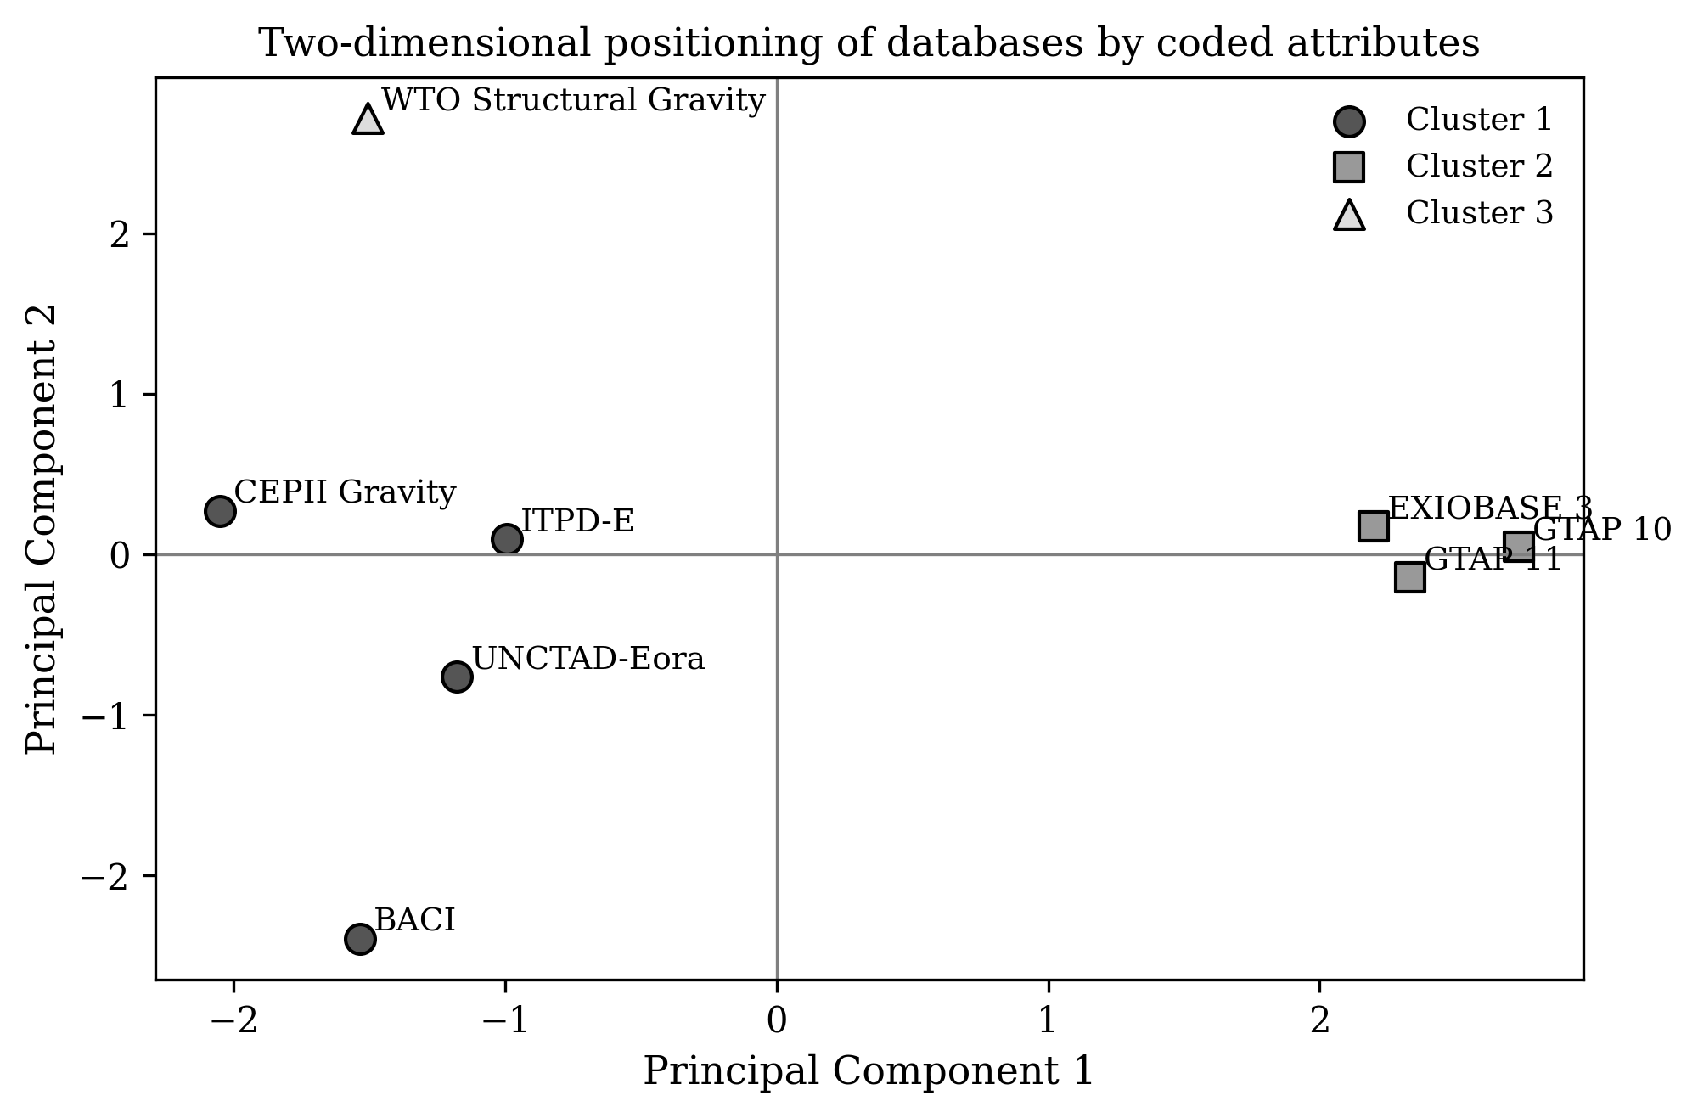
Figure 2. Principal-component positioning of the eight databases based on the coded comparison framework.
Figure 2 shows three intuitive tendencies. First, EXIOBASE 3 and the two GTAP releases occupy the upper-right analytical space associated with integrated modelling capability. Second, CEPII Gravity, ITPD-E, and UNCTAD-Eora fall closer to the centre-left, indicating broad usefulness but a less extension-heavy architecture. Third, BACI and the WTO Structural Gravity Database pull in opposite directions: BACI toward deep, product-level export intelligence and the WTO dataset toward targeted policy estimation in manufacturing. This visual separation is useful because it confirms that database families reflect design logics rather than random stylistic differences.
Table 3. Cluster interpretation based on coded attributes.
Cluster | Databases | Interpretation
Cluster A | EXIOBASE 3; GTAP 10; GTAP 11 | Integrated modelling platforms with high analytical richness and strong suitability for policy or sustainability workflows
Cluster B | UNCTAD-Eora; ITPD-E; CEPII Gravity; BACI | Broad statistical and monitoring platforms with differentiated strengths in coverage, estimation, or export intelligence
Cluster C | WTO Structural Gravity | A specialised policy-estimation dataset built for structural-gravity work in manufacturing trade
The clustering results in Table 3 are substantively plausible. Cluster A contains databases that support integrated modelling, whether the final goal is sustainability accounting or policy simulation. Cluster B is more heterogeneous, but the common trait is that these databases are often used as empirical infrastructures feeding other methods rather than standing alone as complete policy engines. Cluster C is small because the WTO Structural Gravity Database is highly specialized; it is designed less as a general-purpose warehouse and more as a focused estimation platform. Specialization in this case should not be read as weakness. For some questions, it is precisely the desired property.
Scenario-based ranking provides the most decision-relevant result of the paper. In the sustainability footprint scenario, EXIOBASE 3 receives the highest score because its environmental extensions and established footprint applications outweigh its more modest time span. This is consistent with recent work showing that EXIOBASE-based accounting remains particularly useful when services, capital, biodiversity, and indirect supply-chain effects must be considered together (Font Vivanco, 2020; Steubing et al., 2022; Davin et al., 2024).
In the trade-policy counterfactual scenario, GTAP 11 ranks first, followed by GTAP 10. This is not surprising. GTAP was built for calibrated policy analysis and retains a comparative advantage where tariff, carbon, or welfare shocks must be propagated through an internally coherent global system. Recent policy studies on carbon border adjustment and sanctions continue to confirm the value of such architecture for counterfactual work (Korpar et al., 2023; Flach et al., 2024).
In the export diversification scenario, BACI moves to the top. Product-level detail and long temporal coverage are decisive when the objective is to trace structural change, identify related export spaces, or detect shifts in specialization. In this type of work, extreme macro balance is less important than detailed customs resolution. That is why databases optimized for equilibrium simulation do not dominate this scenario despite their broader modelling power (Olvera and Spinola, 2025).
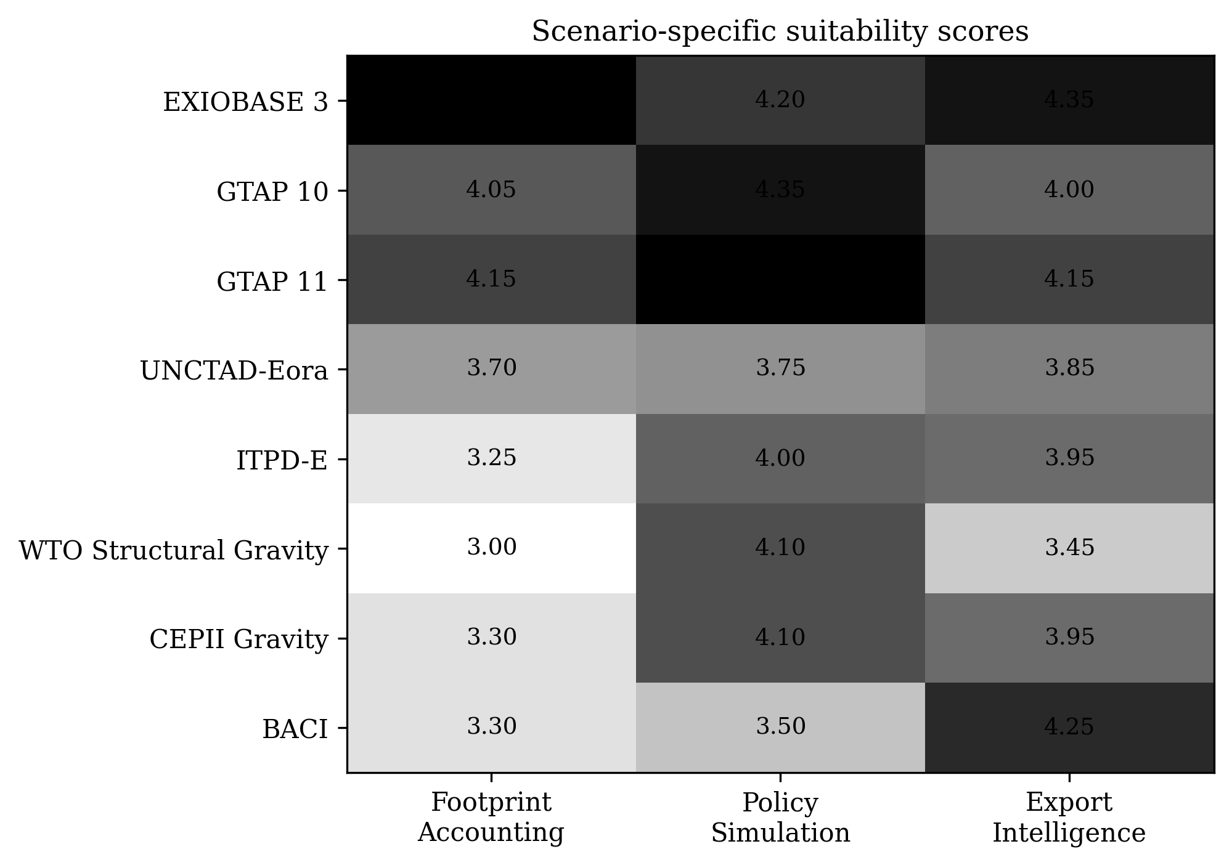
Figure 3. Scenario-specific suitability scores for the benchmarked databases.
The heatmap translates the previous multivariate results into a more practical language. It shows not only who ranks first in each scenario, but also where trade-offs arise. For example, ITPD-E and CEPII Gravity do not lead the footprint scenario, yet they remain competitive in estimation-oriented settings. This intermediate profile explains why they frequently appear in empirical projects that need a bridge between broad country coverage and econometric tractability.
Table 4. Top-ranked databases by application scenario.
Scenario | 1st | 2nd | 3rd
Sustainability footprint accounting | EXIOBASE 3 | GTAP 11 | GTAP 10
Trade-policy counterfactual analysis | GTAP 11 | GTAP 10 | EXIOBASE 3
Export diversification intelligence | BACI | EXIOBASE 3 | ITPD-E / CEPII Gravity
Figure 3 and Table 4 together show why generic claims about the “best” trade database are unhelpful. The answer changes with the analytical scenario. The more useful question is which database fits the structure of the method and the type of inference sought. Once that question is asked directly, database choice becomes clearer and more defensible.
One more result deserves emphasis. UNCTAD-Eora and ITPD-E do not dominate any one scenario, but they remain highly valuable bridging databases. UNCTAD-Eora is especially useful when a study wants broad coverage and GVC indicators without the heavy environmental machinery of EXIOBASE. ITPD-E is particularly attractive when researchers need consistent domestic and international trade-production information for econometric work. In practical terms, these databases often function as robust middle-ground solutions. Their strength is flexibility rather than extremity.
5. Discussion
The findings have methodological implications for both researchers and software developers. For researchers, the most important implication is that database selection should be made before the model is written, not after. Too often, a method is chosen first and a database is attached later as a convenience. The evidence in this article suggests the reverse sequence is safer. Databases encode strong assumptions about aggregation, balancing, environmental scope, and the treatment of domestic trade. Those assumptions influence what the model can legitimately say.
For software developers, the message is slightly different. Analytical tools that support multiple databases should not treat them as interchangeable back ends. A well-designed pipeline should expose database-specific strengths and constraints at the level of data ingestion, harmonisation, and output interpretation. This is particularly important in open scientific computing, where users may not fully understand the structural differences among MRIO, gravity, and customs databases. A database-aware analytical interface is therefore not a luxury; it is a reproducibility feature.
The results also clarify why some empirical debates appear more unsettled than they really are. Consider the common tension between environmental footprint studies and policy simulation studies. These communities sometimes appear to disagree on which datasets are most reliable, but the benchmark suggests they are often optimizing for different inferential goals. EXIOBASE performs very well when environmental extensions drive the question. GTAP performs very well when scenario propagation and welfare logic drive the question. Both are reasonable choices within their own analytical frames.
A similar point applies to export intelligence and diversification research. Product-level customs databases such as BACI are not weaker versions of economy-wide simulation databases; they are built to answer a different class of questions. Their superior detail allows researchers to identify relatedness, concentration, and micro-structural change that would disappear in broader sector aggregates. This makes them especially useful for industrial strategy, trade promotion, and competitiveness diagnostics (Olvera and Spinola, 2025).
The benchmark also sheds light on the growing interest in hybrid questions. Studies on pandemic exposure, sanctions, logistics, employment, and sustainability increasingly cross database families. Pandemic and lockdown research, for example, benefits from MRIO structure because shock transmission is networked rather than local (Ayadi et al., 2022; Bai et al., 2022; Li et al., 2023). By contrast, sanctions and trade-agreement work often relies on gravity-style estimation because the key issue is the response of bilateral flows to changing frictions (Campos et al., 2021; Flach et al., 2024). The lesson is not that one family should replace another, but that hybrid analytical agendas require greater clarity about the database-method fit.
This study has limitations. The coding exercise necessarily compresses complex database architectures into comparable scores. Some users may assign slightly different values to openness, policy readiness, or application diversity. That is acceptable, because the real contribution here is the framework rather than a claim of immutable numeric truth. A second limitation is that the empirical comparison evaluates databases as research infrastructures, not as providers of raw transactions ready for direct balance-sheet auditing. Future work could extend this benchmark by linking coded attributes to actual estimation outcomes across replicated case studies.
Even with these caveats, the benchmark remains useful because it formalizes a decision that is often made informally. The paper converts database choice from a tacit habit into an explicit and discussable part of research design. That alone improves transparency.
The same logic extends to diagnostic studies of vulnerability within a single economy. Once the goal shifts from broad benchmarking to identifying the weak spots of a national production network, databases that support decomposition analysis become valuable complements to the main benchmark. Recent decomposition work on selected economies shows how database structure shapes the visibility of vulnerable sectors and transmission channels, reinforcing the argument that database choice and substantive conclusions are tightly linked (Kuzmenko and Čechura, 2023).

5.1 Practical guidelines for database-aware research design
Finally, developers of analytical packages should consider adding database recommendation layers into their tools. A simple decision screen based on research purpose, required output, geographic focus, and modelling style would reduce avoidable misuse. Such a feature would also improve teaching. Students and early-stage researchers often learn databases through code examples without fully understanding why one source is being used instead of another. A database-aware recommendation layer would make the logic visible and would turn selection itself into a teachable methodological step.
A fourth guideline is to be realistic about middle-ground solutions. In applied work, researchers often do not need the most detailed possible database; they need the most appropriate one under time, access, and reproducibility constraints. This is where databases such as UNCTAD-Eora and ITPD-E become particularly valuable. They may not be the strongest performer in any single extreme scenario, but they frequently provide the best compromise between breadth, usability, and methodological clarity. For many empirical projects, especially those at the interface of academic and policy work, that compromise is more valuable than a marginal gain in detail on one dimension.
A third guideline concerns transparency in software pipelines. Database choice should be documented in the same place as model assumptions, not hidden in preprocessing scripts. A robust pipeline should make explicit the reference year, balancing conventions, country coverage, sector or product mapping, and any environmental or social satellite accounts that are merged into the final analytical object. This is especially important when a single software package supports multiple back ends. The benchmark developed here suggests that a good interface should tell the user not only how to load a dataset, but also what kinds of claims the dataset is best suited to support.
A second guideline is to treat aggregation as a source of substantive uncertainty, not as a harmless technical step. The same economy can appear more or less exposed to shocks depending on whether it is represented through products, industries, or heavily aggregated sectors. This is one reason why EXIOBASE-derived results may differ from those built on broader GVC monitoring systems, and why BACI-style customs intelligence can reveal structural changes that are invisible in coarser sectoral frameworks. Researchers should therefore report the aggregation logic behind the chosen database and, where feasible, run at least one robustness check with a database from a neighbouring family. Such cross-database triangulation is often more informative than a single additional regression.
A first practical guideline is to start from the inferential target rather than from the database brand. If the target is to estimate how bilateral frictions change trade flows under alternative agreements or sanctions, the researcher should favour a gravity-oriented database whose construction is consistent with the assumptions of the estimating equation. In that context, WTO Structural Gravity, CEPII Gravity, and ITPD-E offer a more defensible starting point than an environmental MRIO. If the target is to trace embodied emissions, land use, biodiversity, or service-related upstream impacts, then a database with environmental extensions becomes the natural first choice. The benchmark confirms that this simple reversal in workflow—question first, database second, model third—reduces the risk of methodological mismatch.
6. Conclusion
This article examined eight real trade and MRIO databases through a structured empirical benchmark focused on analytical fit rather than mere scale. The results show that the database landscape is functionally differentiated. EXIOBASE 3 is the strongest option for sustainability footprint accounting; GTAP 11 is the strongest option for trade-policy counterfactual analysis; and BACI is the strongest option for export diversification intelligence. UNCTAD-Eora, ITPD-E, CEPII Gravity, and the WTO Structural Gravity Database occupy valuable intermediate or specialised roles that become visible once the analytical scenario is clearly specified.
The broader conclusion is simple. Database choice is not a preliminary housekeeping step. It is a substantive methodological decision that conditions the credibility, scope, and policy relevance of empirical results. For that reason, future software and research design in trade analytics should become more database-aware, more scenario-explicit, and more transparent about fit-for-purpose selection.
Declaration of AI-assisted language editing
During the preparation of this manuscript, language-model assistance was used only for English polishing and document organisation. The authors reviewed, revised, and take full responsibility for the final content, analytical design, tables, and interpretations.
References
Tukker, A., & Dietzenbacher, E. (2013). Global multiregional input-output frameworks: An introduction and outlook. Economic Systems Research, 25(1), 1–19. https://doi.org/10.1080/09535314.2012.761179
Tukker, A., Poliakov, E., Heijungs, R., Hawkins, T., Neuwahl, F., Rueda-Cantuche, J. M., Giljum, S., Moll, S., Oosterhaven, J., & Bouwmeester, M. (2009). Towards a global multi-regional environmentally extended input-output database. Ecological Economics, 68(7), 1928–1937. https://doi.org/10.1016/j.ecolecon.2008.11.010
Wood, R., Hawkins, T. R., Hertwich, E. G., & Tukker, A. (2015). Global sustainability accounting—Developing EXIOBASE for multi-regional footprint analysis. Sustainability, 7(1), 138–163. https://doi.org/10.3390/su7010138
Stadler, K., Wood, R., Bulavskaya, T., Södersten, C.-J., Simas, M., Schmidt, S., Usubiaga, A., Acosta-Fernández, J., Kuenen, J., Bruckner, M., Giljum, S., de Koning, A., Merciai, S., & Tukker, A. (2018). EXIOBASE 3: Developing a time series of detailed environmentally extended multi-regional input-output tables. Journal of Industrial Ecology, 22(3), 502–515. https://doi.org/10.1111/jiec.12715
Bjelle, E. L., Többen, J., Stadler, K., Kastner, T., Theurl, M. C., Erb, K.-H., & Wood, R. (2020). Adding country resolution to EXIOBASE: Impacts on land use embodied in trade. Journal of Economic Structures, 9, 14. https://doi.org/10.1186/s40008-020-0182-y
Font Vivanco, D. (2020). The role of services and capital in footprint modelling. The International Journal of Life Cycle Assessment, 25(2), 280–293. https://doi.org/10.1007/s11367-019-01687-7
Steubing, B., de Koning, A., Merciai, S., & Tukker, A. (2022). How do carbon footprints from LCA and EEIOA databases compare? A comparison of ecoinvent and EXIOBASE. Journal of Industrial Ecology, 26(4), 1406–1422. https://doi.org/10.1111/jiec.13271
Davin, K., Koslowski, M., Dorber, M., & Hertwich, E. (2024). Examining global biodiversity accounts: Implications of aggregating characterization factors from elementary flows in multi-regional input–output analysis. Journal of Industrial Ecology, 28(6), 1422–1434. https://doi.org/10.1111/jiec.13556
Aguiar, A., Chepeliev, M., Corong, E. L., McDougall, R., & van der Mensbrugghe, D. (2019). The GTAP Data Base: Version 10. Journal of Global Economic Analysis, 4(1), 1–27. https://doi.org/10.21642/JGEA.040101AF
Aguiar, A., Chepeliev, M., Corong, E. L., & van der Mensbrugghe, D. (2022). The Global Trade Analysis Project (GTAP) Data Base: Version 11. Journal of Global Economic Analysis, 7(2), 1–37. https://doi.org/10.21642/JGEA.070201AF
Borchert, I., Larch, M., Shikher, S., & Yotov, Y. V. (2021). The International Trade and Production Database for Estimation (ITPD-E). International Economics, 166, 140–166. https://doi.org/10.1016/j.inteco.2020.08.001
Yotov, Y. V. (2024). The evolution of structural gravity: The workhorse model of trade. Contemporary Economic Policy, 42(4), 578–603. https://doi.org/10.1111/coep.12666
Campos, R. G., Timini, J., & Vidal, E. (2021). Structural gravity and trade agreements: Does the measurement of domestic trade matter? Economics Letters, 208, 110080. https://doi.org/10.1016/j.econlet.2021.110080
Yanikkaya, H., & Altun, A. (2020). The impact of global value chain participation on sectoral growth and productivity. Sustainability, 12(12), 4848. https://doi.org/10.3390/su12124848
Taguchi, H., & Zhao, J. (2022). China’s global value chain linkage and logistics performances in emerging ASEAN economies. International Studies of Economics, 17(2), 126–155. https://doi.org/10.1002/ise3.12
Li, C., Zhang, X., Su, B., Egger, P., & Wiedmann, T. (2023). Responses to the COVID-19 pandemic have impeded global and national sustainability goals. Communications Earth & Environment, 4, 278. https://doi.org/10.1038/s43247-023-00914-2
Bai, S., Wang, Y., Wang, H., & Liu, Y. (2022). Does lockdown reduce employment in major developing economies? An assessment based on multiregional input-output model and scenario analysis. Sustainability, 14(12), 7128. https://doi.org/10.3390/su14127128
Kuzmenko, E., & Čechura, L. (2023). Decomposition analysis of global value chains: Uncovering vulnerable spots in a selected economy (the example of Czechia). Heliyon, 9(5), e15763. https://doi.org/10.1016/j.heliyon.2023.e15763
Ayadi, R., Giovannetti, G., Marvasi, E., & Vannelli, G. (2022). Demand and supply exposure through global value chains: Euro-Mediterranean countries during COVID. The World Economy, 45(3), 637–656. https://doi.org/10.1111/twec.13156
Flach, L., Heiland, I., Larch, M., Steininger, M., & Teti, F. A. (2024). Quantifying the partial and general equilibrium effects of sanctions on Russia. Review of International Economics, 32(1), 281–323. https://doi.org/10.1111/roie.12707
Olvera, B. C., & Spinola, D. (2025). Determinants of export diversification in resource-dependent economies: The role of product relatedness and macroeconomic conditions. Structural Change and Economic Dynamics, 74, 578–590. https://doi.org/10.1016/j.strueco.2025.05.019
Korpar, N., Meliciani, V., & Timini, J. (2023). The European carbon border adjustment mechanism as a trade and climate policy tool. International Economics and Economic Policy, 20(1), 97–135. https://doi.org/10.1007/s10368-022-00550-9

